Lab 3

Singly Linked List

Objective:
The objective of this lab is to implement Linear Singly Linked List.

Introduction:
A singly linked list is a collection of components, called nodes. Every node (except the last node) contains the address of the next node. Thus, every node in a linked list has two components: one to store the relevant information (that is, data) and one to store the address, called the link, of the next node in the list. The address of the first node in the list is stored in a separate location, called the head or first. Last node to list points to NULL.

Properties:
- Singly linked list can store data in non-contiguous locations.
- Insertion and deletion of values is efficient with respect to Time and Space Complexity.
- Dynamic structure (Memory Allocated at run-time).
- Nodes can only be accessed sequentially. That means, we cannot jump to a particular node directly.
- There is no way to go back from one node to previous one. Only forward traversal is possible.

Basic Functionality:
- Insertion of new node in Singly Linked List

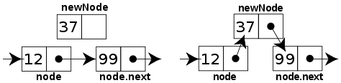

Insertion

- Deletion of node from Singly Linked List

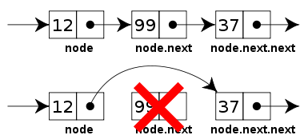
Deletion

- Searching a node based on content. If the specified node is not present in the list an error message should be displayed.

Exercise 1: Implement a singly linked list.
Implement all the methods given in the following class definition for singly linked list. Your code should work for the main function that follows.

template<typename T>
class Node
{
public:
// constructor
Node(T element);

//sets the KeyType data in the Node
voidsetData(T pVal);

// returns the KeyType data in the Node
T getData();

// returns the link to the next node
Node* GetNext();

// sets the link to the next node
voidSetNext(Node *x);

private:
T data;
Node *link ;
};

template<typename T>
class List
{
public:
// constructor of the Singly Linked List
List();

//Inserts the node pNew after the node pBefore
// if the list is empty, it makes pNew the first node of the list
void Insert(Node<T>* pBefore, Node<T>* pNew);

//Deletes the node pToBeDeleted
void Delete(Node<T>* pToBeDeleted);

//prints the contents of the list
void printList();

void DeleteMin();
//finds and deletes the min element in complete link list
//If there are more than one nodes with minimum value //than this function will delete all the nodes with //minimum value

private:
Node<T> *first ;

};

int main()
{
Node<int> *a, *b, *c, *d, *e;

a = new Node<int>(1);
b = new Node<int>(2);
c = new Node<int>(3);
d = new Node<int>(4);
e = new Node<int>(5);

List<int> *list;

list = new List<int>();

list->Insert(0 , a);
list->Insert(a , b);
list->Insert(b , c);
list->Insert(a , d);
list->Insert(b, e);

list->printList();

list->Delete(a);

cout<<"\nAfter deleting first node"<<endl;
list->printList();

list->DeleteMin();

list->printList();

system("pause");
return 0;

}

POST LAB:
Implement all the methods given in the following class definition for Singly Circular linked list. Implement a client program as well which demonstrates use of the functions of singly circular linked list

Circular Singly Linked List:
A linked list in which the last node points to the first node is called a circular linked list.
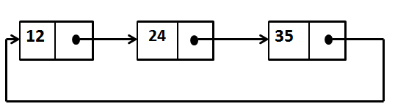
Singly Circular Linked List
template<typename T>
class Node
{ public:
// constructor
Node(T element);
//sets the KeyType data in the Node
voidsetData(T pVal);
// returns the KeyType data in the Node
T getData();
// returns the link to the next node
Node* GetNext();
// sets the link to the next node
voidSetNext(Node *x);
private:
T data;
Node *link;
};
template<typename T>
classSCList
{public: // constructor of the Singly Circular Linked List
SCList();
/*Inserts the node pNew after the node pBefore
if the list is empty, it makes pNew the first node of the list*/
void Insert(Node<T>* pBefore, Node<T>* pNew);
//Deletes the node pToBeDeleted
void Delete(Node<T>* pToBeDeleted);
//prints the contents of the list
voidprintList();
private:
Node<T> *last ;
};

